**Google Sign In Extension**

Contents

**Introduction** **2**

**Extension’s Features** **3**

**Setup** **4**

**Functions** **7**

GoogleSignIn_Show(webClientID) 7

GoogleSignIn_SignOut() 7

# Introduction

Google Sign-In manages the OAuth 2.0 flow and token lifecycle, simplifying your integration with Google APIs.

# 

# Extension’s Features

* Show sign-in account selector.
* Sign out of your account.

# Setup

The Google Sign In extension requires the developer to provide the web client Id for the project the user is signing In to. To get this identifier the user can follow the following steps:

1. Go to Google Cloud Platform [Credentials and APIs](https://console.cloud.google.com/apis/credentials) page and select your project.
2. On the top of the screen click to **Create Credentials**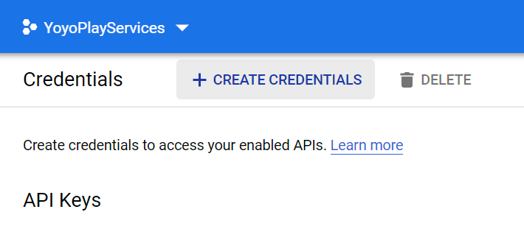
3. Select the **OAuth client ID** option from the dropdown.  
   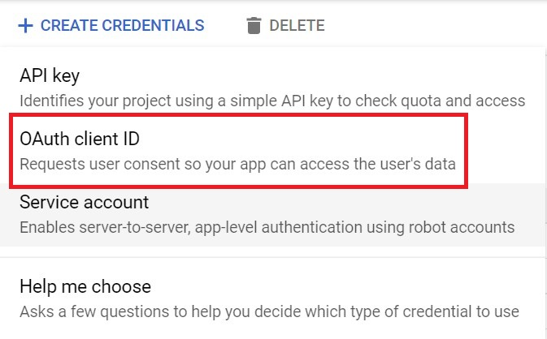
4. For application type select **Web Application** and then give your OAuth client ID a name.   
     
     
     
   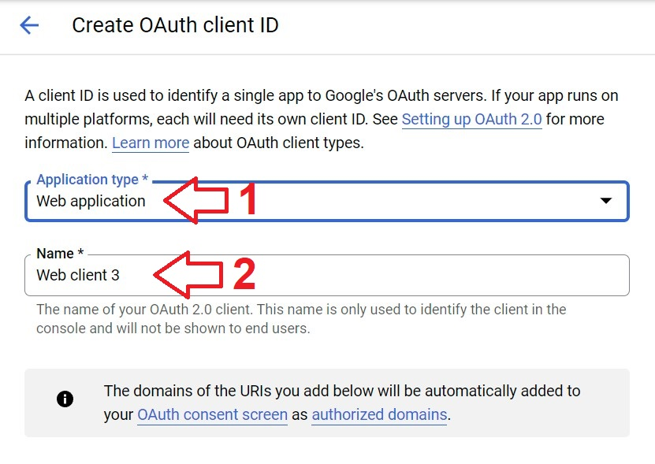
5. Done, you should now be ready to use the Google SignIn Extension by providing the ID that can be found in the image below (click in the icon to copy the Web Client ID).  
   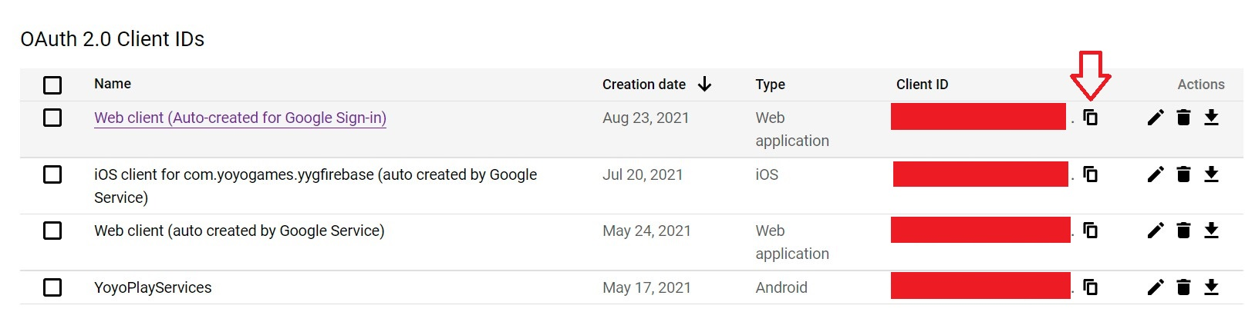
6. For **iOS** the ID also needs to go into the extension configuration (double click the extension and go to **Extra Platforms → iOS**)  
   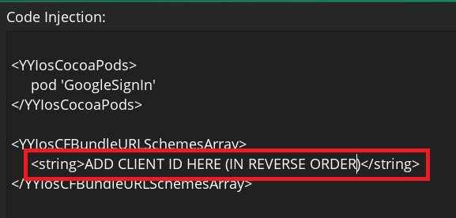  
   It’s important to note that the ID needs to go in the reverse order (ie.: **UUID.apps.googleusecontent.com** becomes **com.googleusercontent.apps.UUID**).

# Functions

The provided functions generate **Async** **Social Event** callbacks. In these cases the extension populates the **async_load** map with a "**type**" key that will have the same value as the function that triggered the callback.

### GoogleSignIn_Show(webClientID)

Description: Shows the google overlay popup to select a google account to sign up with. This is an asynchronous function that will trigger the **Async Social** event when the task is finished.

Params:

*{string}* **webClientID** The web client Id that is obtained through the google cloud console (follow Setup steps).

Returns: N/A

Triggers: Asynchronous Social Event

*{string}* **type** The constant ***“GoogleSignIn_Show”***.

*{boolean}* **success** Whether or not the requested task was successful.

*{string}* **idToken** An ID token (authentication token) that you can send to your server.

### GoogleSignIn_SignOut()

Description: Signs out the current signed-in user if any. This is an asynchronous function that will trigger the **Async Social** event when the task is finished.

Returns: N/A

Triggers: Asynchronous Social Event

*{string}* **type** The constant ***“GoogleSignIn_SignOut”***.

*{boolean}* **success** Whether or not the requested task was successful.